WordClock 5
Multi-Color LED Word Clock
User's Guide

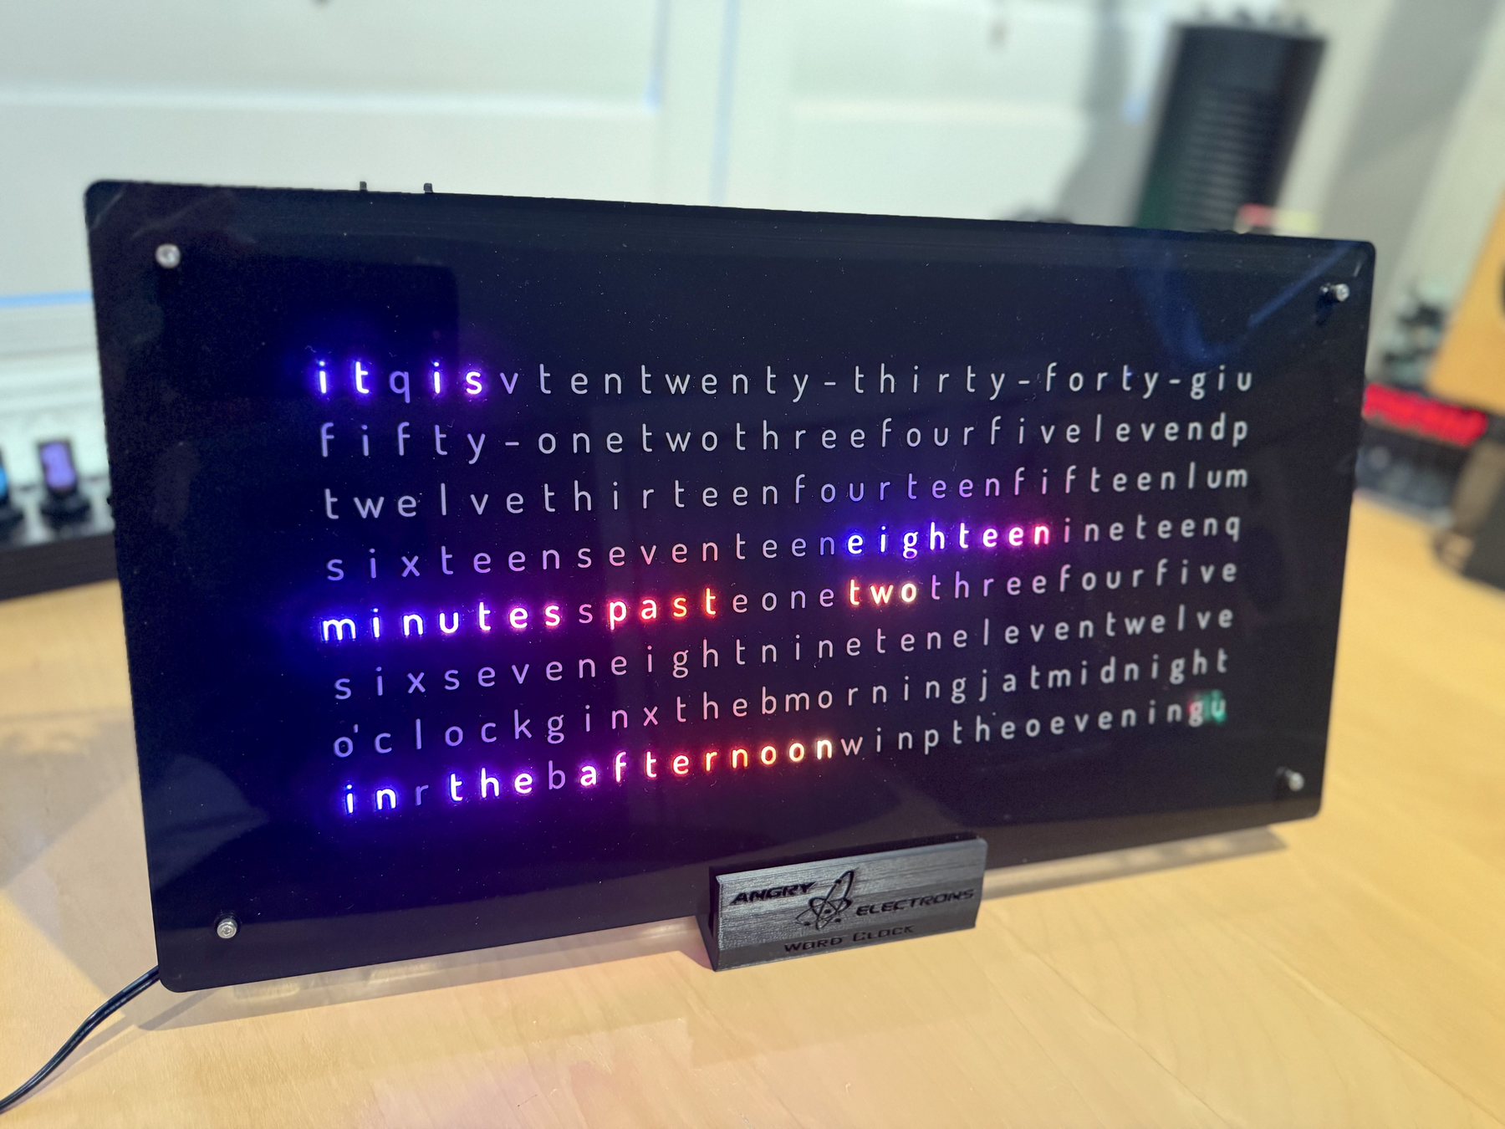
October 2026
This guide describes the setup, configuration, and day-to-day operation of the WordClock 5 — a WiFi-connected, multi-color LED word clock built around the Angry Electrons software platform.
Revision/Update Information: | Revision 8 — October 2026
Clock Firmware: | V4.4
Designed by Mitchell Feig
Copyright © 2025–2026 Mitchell Feig — Distributed by StocksClocks LLC

Table of Contents

Quick Start QS-1
1. Overview 1-1
2. Models 2-1
3. Display 3-1
4. Buttons 4-1
5. Power-On Functions 5-1
6. AP Configuration Mode 6-1
7. Live Settings Web Interface 7-1
8. Rule Scheduler 8-1
9. Animations 9-1
10. NTP Time Sync 10-1
11. Announcements 11-1
12. Format Files 12-1
13. Over the Air Update 13-1
14. Troubleshooting 14-1

Quick Start

Follow these steps to set up the WordClock 5 for the first time. A full explanation of every option is in the numbered sections that follow.

1. Power on
Connect a 5V DC power supply to the clock. The barrel connector is 5.5/2.1 mm, center positive. Minimum current rating is 2 A for single-board clocks and 4 A for double- or triple-board clocks.
The clock is reverse-voltage protected, but it is NOT protected against higher voltages. A 12 V supply will most likely destroy every LED on every board. Verify the supply rating before plugging it in.

2. Enter AP configuration mode (automatic on first power-on)
A brand-new clock starts in AP configuration mode automatically. The display blinks "AP" to indicate it is waiting to be set up. (On a previously-configured clock that already has WiFi credentials, the clock proceeds directly to step 5 — to reconfigure WiFi, hold SW2 for 5 seconds while the time is displayed.)

3. Connect to the clock's WiFi
From a phone or computer, open the WiFi settings and connect to the network named WordClock-5. No password is required.

4. Configure in a browser
Open a web browser and go to 192.168.4.1. The setup page loads. At minimum:
- Select the home WiFi network from the SSID dropdown and enter its password. On a clock with no saved network the list starts on "-- select your network --"; select the home network before pressing Start.
- Confirm the UTC offset for the local region (US Eastern is 5 hours, Minus, by default).
Tap Save below the last field. The clock saves the settings and starts.

5. Wait for time to appear
On a successful boot, the display shows "WC5" briefly, then "WiFi" while connecting to the network, then "NTP" while fetching time from the internet, then the current time. The whole sequence usually completes within a few seconds.
If the WiFi connection and NTP sync have not both completed within about two minutes, the clock reboots and tries again. After three failed boots in a row (for example a wrong WiFi password or a renamed network), the next boot starts AP mode instead, so the WiFi settings can be corrected at 192.168.4.1. Because each attempt allows about two minutes, this takes several minutes. This forced AP mode lasts for that one boot only: correct the settings and press Start to save them and reboot into normal operation. Pressing Save without Start stores the settings but does not keep the clock in AP mode; the next power-cycle tries the saved network again. If the network was only temporarily down (router rebooting, internet outage), power-cycling the clock returns it to normal operation.

6. Daily use
To do this | Do this
Change brightness temporarily | Click SW2 to cycle through ten brightness levels
Cycle through color effects | Click SW1 — effects cycle in the order shown in setup
Suspend an active rule | Click SW1 — standard settings return for the Rules Timeout duration
See the clock's IP address | Double-click SW1 — IP and mDNS hostname scroll across the matrix
Adjust most any setting live | Browse to the clock's IP address (or http://<ap-name>.local/) from any device on the same WiFi
Enter AP configuration mode | Hold SW2 for 5+ seconds while the time is displayed
Install new software over WiFi | Hold SW1 for 10 seconds while the time is displayed (20+ seconds for beta firmware)
Cycle the board / LED variant | Hold SW2 while applying power; release when the digit appears, repeat until correct
Factory reset | Hold SW1 and SW2 while applying power; release when "WC5" appears
Format-file debug mode | Hold SW1 when "WC5" is displayed; release after the screen clears

7. Recommended next steps
- Browse the live settings page on the home WiFi network and explore the available animations and LED effects.
- Open the Rule Editor and add one or two rules to dim or change settings during sleeping hours.
- If using a multi-language or multi-board configuration, install an SD card with the appropriate format file.

1. Overview

The WordClock 5 displays the time in words, drawn from what appears at first glance to be a random matrix of letters. The matrix is eight rows deep and either sixteen, thirty-two, or forty-eight columns wide — built from one, two, or three sixteen-column boards connected together.
Display precision varies with the board count. The single-board version displays time to the nearest five minutes. The double-board version adds enough words to display time to the minute. The triple-board version additionally displays seconds.
Several languages are available. The clock animates the display in full color with a wide selection of effects and transitions, all selectable through a web setup page or with the two buttons on the clock.
WordClock 5 connects to internet NTP servers for time. Daylight Saving Time adjustments are automatic. An open-source format file is used for each version and each language, so users may adjust and customize the layout as they please.

Features
- Initial setup and configuration through a web browser on a PC or mobile device.
- Live settings page for runtime adjustments from any device on the same WiFi — no reboot required.
- UTC offsets including 30- and 45-minute time zones, for use anywhere in the world.
- Automatic Daylight Saving Time start and end with configurable rules.
- Connects to open or password-protected WiFi networks.
- Rule Scheduler with time-range rules — dim, change effects, or blank the display by hour, day, or weekend/weekday.
- Optional date display at a configurable second of each minute, with selectable format and color.
- Optional SD-card announcements file for date- and weekday-based custom messages.
- User-editable format files on SD card for layout and language customization.

2. Models

Three model variants share this software platform. The model is determined by the number of display boards connected together.
Model | Boards | Matrix Size | Time Precision
WC5 Single | 1 | 8 rows × 16 columns | Five minutes
WC5 Double | 2 | 8 rows × 32 columns | One minute
WC5 Triple | 3 | 8 rows × 48 columns | One second

The single-board English version has its format file built in. Other languages and the double- or triple-board configurations require an SD card containing the appropriate format file. See Section 12: Format Files.

3. Display

The clock displays time as illuminated words drawn from the letter matrix. Outside of normal time display, several short status messages appear on the screen:
Display | Meaning
WC5 | Boot indicator. Shown briefly when the clock starts. The W should be red, C green, and 5 blue. If the colors appear in any other order, the wrong boardType is selected — see Section 5: Power-On Functions to cycle through the four boardType variants.
WiFi | Connecting to the configured WiFi network. If this message persists for more than a few seconds, the WiFi password is most likely incorrect.
NTP | Connecting to an NTP time server after the WiFi association has succeeded. Often shown so briefly it is missed.
AP | Access Point configuration mode. The clock is broadcasting its own WiFi network and waiting for setup.
SD Card | The SD card cannot be mounted. It is either missing, formatted incorrectly, or contains no readable format file. Only relevant for single-board clocks running a non-English language and for all double- or triple-board configurations.

On the triple-board version, seconds are part of the normal time display. On single- and double-board versions, the optional Date Display (Section 7) and Announcements (Section 11) features provide additional information during each minute.

Status Display Examples
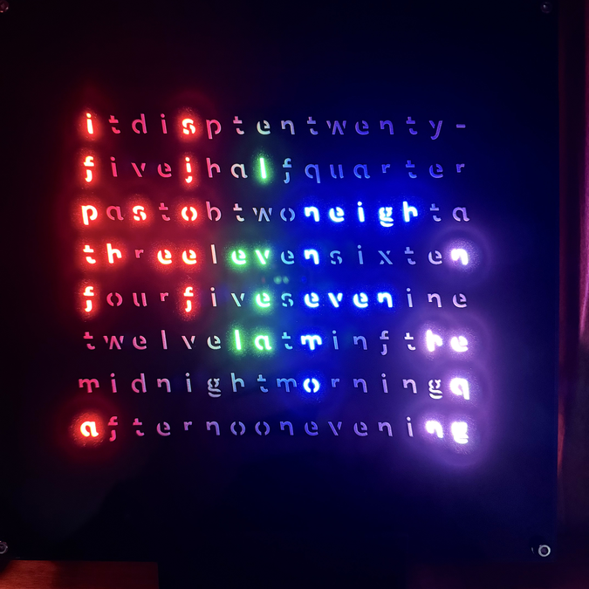
AP — Access Point configuration mode
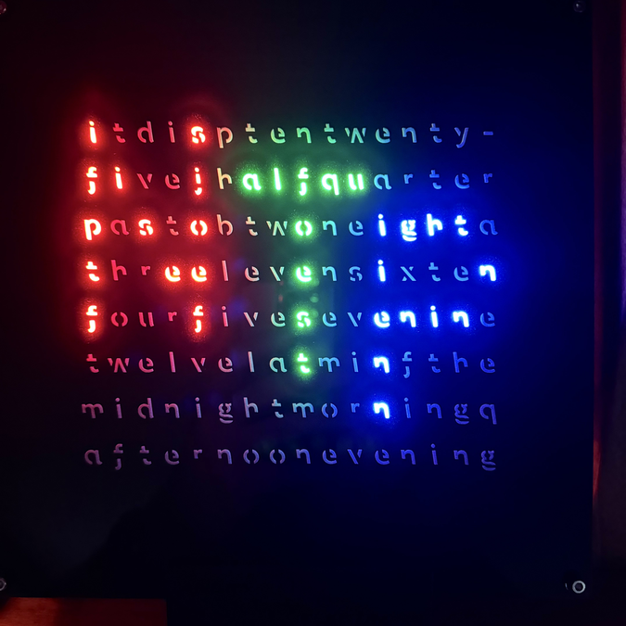
WiFi — connecting to the configured network
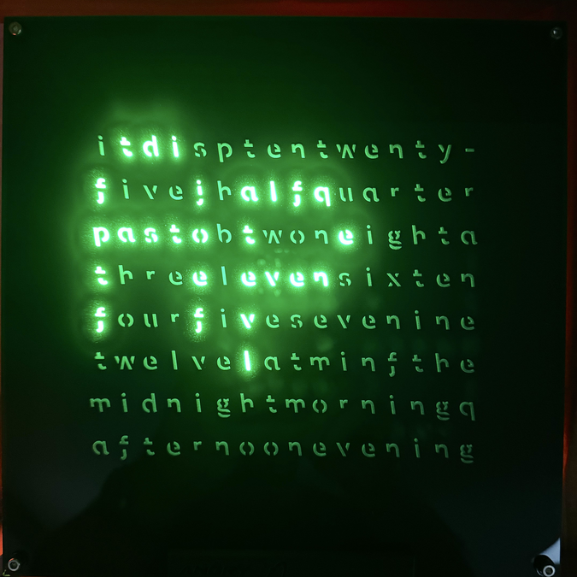
NTP — fetching time from the time server

4. Buttons

The clock has two buttons: SW1 (left) and SW2 (right).

SW1 — During Normal Operation
Action | Function
Single click | Cycle through the configured color effects in the order shown in setup
Single click while a rule is active | Suspend the active rule and restore standard settings for the configured Rules Timeout duration
Double-click | Scroll the clock's IP address and mDNS hostname across the matrix (cyan IP, yellow hostname)
Hold 10 seconds | Start an over-the-air software update with the production firmware
Hold 20+ seconds | Start an over-the-air software update with the beta firmware (appends "b" to the .bin filename)

SW2 — During Normal Operation
Action | Function
Single click | Cycle Nixie LED brightness through ten levels (temporary, not saved to memory)
Hold 5+ seconds | Restart in AP configuration mode. Existing settings are preserved so they can be edited.

Suspending an Active Rule
Pressing SW1 while a Rule Scheduler rule is overriding any field temporarily restores the standard (non-rule) settings. The restoration lasts for the duration set by Rules Timeout (15 Seconds, 1 Minute, or 5 Minutes), then rule evaluation resumes automatically.

5. Power-On Functions

Special functions are available by holding buttons while applying power. The clock latches button state once at power-on, so buttons may be released immediately after the clock starts — there is no need to keep them held through the entire boot sequence.
Buttons Held | Function
SW1 only | LED color cycle test followed by format-file debug mode. All LEDs cycle through red, green, blue, and white for ten seconds; the clock then enters format-file debug mode (rapid time advance) until power is cycled.
SW2 only | Cycle the board / LED variant (boardType 0 → 1 → 2 → 3 → 0). The selected position (1–4) is shown briefly on the matrix so the user can confirm the choice. The setting survives factory resets. See Section 2: Models for which variant matches the installed hardware.
SW1 + SW2 | Factory reset. Clears all saved settings and restarts in AP configuration mode. The boardType selection is preserved.
SW1 while "WC5" is shown | Format-file debug mode. The clock advances time rapidly so format-file changes can be verified across many minutes and hours quickly. Release after the "WC5" message clears.

boardType selects the LED chipset and SPI pin map used to drive the display:
boardType | LED Chipset | SD Card SPI | Board
0 | APA106 | Default (CS=5) | Pico D4
1 | WS2812B | Default (CS=5) | Pico D4
2 | WS2812B | CLK=IO2, MOSI=IO13, CS=32 | Pico V3 (pre-Release 5)
3 | WS2812B | CLK=IO20, MOSI=IO13, CS=32 | Pico V3 (Release 5)

If "WC5" does not boot in W=red / C=green / 5=blue order, or the SD card does not mount, cycle SW2 at power-on until the correct variant is selected.

6. AP Configuration Mode

Entering AP Mode
- Hold SW2 for 5+ seconds while the time is displayed, OR
- Apply power with SW1 and SW2 both held (factory reset + AP mode), OR
- Power on a brand-new clock — it starts in AP mode automatically, OR
- After three boots in a row that fail to connect to WiFi and sync the time, the next boot starts AP mode for that one boot (see Quick Start, step 5). Press Start after correcting the settings; power-cycling instead retries the saved network.
The display blinks "AP" to indicate the clock is in AP configuration mode.

Connecting
1. Connect a phone or computer to the WiFi network named WordClock-5.
2. Open a web browser and go to 192.168.4.1.
3. Adjust settings (described below) and press Save. The clock saves all settings and starts.
All hourly times use the 24-hour clock.

Network Settings
Setting | Description
Access Point Name | WiFi network name when in AP mode, and the basis for the mDNS hostname (default: WordClock-5-N where N is the detected board count).
SSID | Select the home WiFi network from the dropdown. The list is rescanned each time AP mode is entered. Spaces within an SSID may display but can fail to associate.
SSID Override | Manually typed SSID for networks that do not appear in the scan (e.g. hidden networks). When non-empty it takes precedence over the dropdown selection.
Network Password | WiFi password for the selected SSID. Maximum length 63 characters.
Live Form Password | Optional password gating the live settings page on the home network. Leave blank to disable password protection.
NTP Server | Primary time server hostname (default: us.pool.ntp.org). See Section 10 for guidance on NTP server selection.
Alternate NTP Server | Fallback time server. Tried when the primary fails to respond. Default: time.google.com. Leave blank to disable rotation.

Display Settings
Setting | Options | Default
Brightness | 0–9 | 9
Animation | Falling Letters, Wandering Letters, The Matrix, Scroll, Hurricane, Tornado, Cycle | Cycle
Animation Interval | Off, 1 Minute, 5 Minutes, 10 Minutes, 15 Minutes, 30 Minutes, 1 Hour | 1 Minute
Effect | Rainbow 1, Rainbow 2, Pulsing, Sweep, Twinkle, Red, Green, Blue, White, Cycle | Cycle

Announcements
Setting | Options | Default
Announcement Period | Off, 1 Minute, 5 Minutes, 15 Minutes, 30 Minutes, Hourly | 1 Minute
Announcement Color | Red, Green, Blue, Yellow, White, Cycle, Custom Color | Cycle
Custom Color | Color picker (used when Announcement Color = Custom Color) | —

Date Display
Optional once-per-minute date scroll on the matrix. Disabled by default — set Date Format to anything other than Off to enable.
Setting | Options | Default
Date Format | MM/DD/YY, DD/MM/YY, YY/MM/DD, Off | MM/DD/YY
Start Second | 30–50 (second of each minute to begin) | 30
Date Color | Color picker | Green

The Start Second range avoids collisions with animations at the top of the minute and announcements at the half-minute. The scroll completes in under five seconds so it always finishes before the next minute boundary.

Live Settings Form
Setting | Options | Default
Live Settings Form | Enabled, Disabled | Enabled

When disabled, the clock does not serve any web content during normal operation. Re-enabling requires another trip through AP configuration mode.

Rule Editor
The Rule Editor sub-page hosts the Rule Scheduler — a table of time-range rules that replaces the older three-period override system. See Section 8: Rule Scheduler for the full syntax and behavior. The same editor is also reachable from the live settings page on the home network.

Time Zone
Setting | Options | Default
UTC Offset Hours | 0–23 | 5
UTC Offset Minutes | 0, 30, 45 | 0
UTC Offset Direction | Plus, Minus | Minus

Daylight Saving Time
Setting | Options | Default
DST Start Month | Jan–Dec | March
DST Start Week | 1–5 (5 = last week of the month) | 2
DST Start Day | Sun–Sat | Sunday
DST Start Hour | 0–23 | 2
DST Offset | 0 or 1 hours | 1
DST Direction | −, + | +

Standard Time
Setting | Options | Default
ST Start Month | Jan–Dec | November
ST Start Week | 1–5 (5 = last week of the month) | 1
ST Start Day | Sun–Sat | Sunday
ST Start Hour | 0–23 | 2

Default DST and Standard Time settings are configured for US Eastern Time.

OTA Update
Setting | Description
Firmware URL | Base URL of the firmware server. Default: https://mitchsf.github.io/Firmware/. See Section 13 for the over-the-air update flow.

7. Live Settings Web Interface

Once the clock is connected to WiFi, the live settings page is available from any device on the same network. All changes apply immediately as controls are adjusted — no reboot — and a Save action persists changes across power cycles.

Access
Browse to http://<clock-ip-address>/. To find the IP address, double-click SW1 — the clock scrolls the IP (in cyan) followed by its mDNS hostname (in yellow) across the matrix.

Using a Name Instead of an IP Address (mDNS)
On home networks that support mDNS (also called Bonjour or zero-configuration networking), the clock can be reached by name instead of by IP. Browse to http://wordclock.local/ (or whatever the configured Access Point Name resolves to) and the page should load. The hostname is derived from the AP Name set in AP configuration: lowercased, with spaces and any non-alphanumeric characters converted to hyphens. For example, an AP Name of "WordClock" becomes wordclock.local; "Kitchen Clock" becomes kitchen-clock.local. This makes it easy to give each clock in a multi-clock household a memorable, personal address.
mDNS does not work on every network. Some routers — particularly older models or routers with multicast filtering enabled — block the discovery messages mDNS depends on, in which case the .local address will not resolve. macOS, iOS, and Windows 10/11 generally work out of the box; some Android versions and Linux distributions need extra setup. If the .local address does not load, fall back to the IP address (double-click SW1 to display it).

Live Form Password
If a Live Form Password was set in AP configuration, the page prompts for it before any settings appear. Leave the password field blank in AP configuration to disable password protection.

Enabling and Disabling the Live Form
The live form can be turned off entirely from the Display page of AP configuration (Live Settings Form: Enabled / Disabled). When disabled, the clock does not serve any web content while running — useful in shared environments where settings should not be editable after initial setup. Re-enabling requires another trip through AP configuration.

Layout
The live form is split across a Home page and two sub-pages:
- Home — page-navigation buttons, plus a "scroll a custom message" panel.
- Display — brightness, animation, animation interval, effect, and Date Display.
- Rule Editor — Rules Enabled toggle, Rules Timeout, and the full rule list with add / edit / delete / move controls.

Home Page — Scroll a Custom Message
Below the navigation buttons, three controls push an arbitrary text message onto the matrix as a one-shot scroll:
- Message Color — Red, Green, Blue, Yellow, White, or Custom Color
- Custom Color — color picker, used when Message Color is set to Custom Color
- Message — text field up to 63 characters, with a Send button that injects the message into the next available scroll cycle

Display Page
- Display Brightness — 0–9
- Animation — Falling Letters, Wandering Letters, The Matrix, Scroll, Hurricane, Tornado, or Cycle
- Animation Interval — Off, 1 Minute, 5 Minutes, 10 Minutes, 15 Minutes, 30 Minutes, or 1 Hour
- Effect — Rainbow 1, Rainbow 2, Pulsing, Sweep, Twinkle, Red, Green, Blue, White, or Cycle
- Date Format — MM/DD/YY, DD/MM/YY, YY/MM/DD, or Off
- Start Second — 30–50 (second of each minute at which the date scrolls)
- Date Color — color picker

Rule Editor Page
The Rule Editor is the runtime control surface for the Rule Scheduler. Section 8 describes the rule syntax in detail.
- Rules Enabled — temporarily suspend all rules without deleting them. The setting is not saved and reverts to Enabled on the next reboot.
- Rules Timeout — how long SW1 suspends the active rule when pressed (15 Seconds, 1 Minute, or 5 Minutes).
- Rule input — a multi-line text box for entering a new rule or editing an existing one. Tap Apply to save.
- Delete — removes the currently selected rule (tap a row in the schedule to select it).
- Schedule — list of all configured rules. Tap a row to load it into the input for editing; the ↑ / ↓ buttons reorder rules.

Saving Changes
Adjustments to the Display page take effect on the matrix the moment a control is released — useful for trying out animations and effects without commitment. To make those changes permanent, tap Save at the bottom of the page; the clock writes the configuration to flash so it survives a power cycle.
Rule Editor changes (add, edit, delete, reorder) are persisted immediately — there is no separate Save step on that page.

8. Rule Scheduler

The Rule Scheduler holds a list of time-range rules. The maximum number of rules depends on the model and firmware version. When the list is full, the Rule Editor refuses a new rule. If a saved schedule is longer than the limit (for example after a firmware update), only the rules at the top of the list are kept. Each rule applies a partial set of display overrides during a specified window of time and (optionally) a specific subset of days. Rules replace the older three-period override system found on earlier versions of the WordClock firmware.
The editor lives on its own sub-page of both the AP setup form and the live settings form. Add, edit, delete, and reorder operations on the live form are persisted immediately — there is no Save step.

Rule Syntax
A rule is a single line consisting of one time-range token followed by any number of field-override tokens, separated by spaces or commas. The time-range token is required; every other field is optional.
Token | Description
t=H-H | Time range (required). Examples: t=22-6 (22:00 through 05:59), t=5-7 (5:00 through 6:59), t=05:30-07:00. End is exclusive. Bare hour t=5 expands to 5:00–6:00. Cross-midnight ranges (t=22-6) are allowed.
wd | Limit to weekdays (Monday–Friday).
we | Limit to weekends (Saturday and Sunday).
br=0..9 | Display brightness override (0 = off).
an=N | Animation override (index into the Animation list).
at=N | Animation Interval override.
fx=N | Effect override.
cc=RRGGBB | Custom Color override (used by effects that honor a custom color).

Examples:
- t=22-6 br=2 fx=4 — between 10pm and 6am, drop brightness to 2 and switch to Twinkle.
- t=9-17 wd an=2 — during weekday business hours, force the Matrix animation.
- t=0-7 we br=0 — on weekend nights, blank the display entirely.

Editing Rules
On either form's Rule Editor sub-page, type a rule into the input box and tap Apply. Tap a row in the Schedule list to load it back into the input for editing; the editIdx hidden field tracks which row is being edited. Tap Delete to remove the currently selected row. The ↑ and ↓ buttons reorder rules.
A tooltip bubble next to the rule input lists every available token and its allowed values — tap or hover to display.

Evaluation Order
Rules are evaluated once per minute. The scheduler walks the list top-to-bottom and applies every rule whose time and day window currently matches; later rules overlay earlier ones, so the last matching rule wins per field. The Schedule list shows a warning badge next to rows that overlap with rows above them.
Pressing SW1 while any rule is masking a field temporarily restores the standard (non-rule) settings for the Rules Timeout duration. Rule evaluation resumes automatically when the timeout expires.
The "Rules Enabled" toggle on the live form's Rule Editor page suspends all rules without deleting them. It is not persisted to flash and reverts to Enabled on the next reboot — useful for ad-hoc overrides without losing the schedule.

9. Animations

When an Animation Interval is set, the clock plays one of seven animations at the configured cadence (every minute, every five minutes, and so on). All animations resolve to the same final display — only the path each pixel takes to get there differs.
Animation | Description
Falling Letters | Each letter drops vertically from above the matrix into its final cell, with staggered start times so the columns fill in independently.
Wandering Letters | Letters appear at random cells and step toward their final positions one move at a time.
The Matrix | Green "code rain" cascades down every column; each letter is revealed as the rain passes over its final cell.
Scroll | The full time string scrolls horizontally across the matrix and lands at its final position.
Hurricane | Outward spiral. Letter pixels burst from the matrix center to their target cells while decorative "leaf" particles spiral outward, fading as they expand. A quadratic ease-out gives the spiral a dramatic decelerating finish.
Tornado | Inverted-funnel shape: wide at the top, narrowing to a few cells at the bottom. Pixels swirl around the vertical axis, then each letter is thrown to its final cell in random order as the funnel dissipates.
Cycle | Rotates through the six other animations, picking a different one on each animation trigger.

Hurricane and Tornado are computationally heavier than the other animations and look best on double- and triple-board clocks where the extra width gives the spiral and funnel more room to breathe.

10. NTP Time Sync

WordClock 5 obtains the current time from internet NTP (Network Time Protocol) servers. After WiFi associates on boot, the clock contacts the configured NTP server and uses the result to set its internal clock. Daylight Saving Time is then applied automatically from the configured DST rules.

Choosing an NTP Server
The default primary NTP server is us.pool.ntp.org and the default alternate is time.google.com. The clock rotates to the alternate when the primary fails to respond, then back. The NTP Pool Project terms of service ask end users not to make more frequent requests than the pool agreement allows:
"4. End-User agrees that he or she will not:
(a) Change default settings to make more frequent request of the Services, if using an ntp daemon ("NTP Protocol");
(b) Request time from the Services more than once every thirty (30) minutes (ideally at even longer intervals), if using SNTP." (https://www.ntppool.org/tos.html)
A single WordClock 5 polls infrequently and sits well inside this limit, but a household with many clocks all pointed at the same public pool can drift out of compliance. In that case, point each clock at a local time server instead.

Local NTP Servers
Most modern home routers run a built-in NTP server that any device on the home network can use as its time source. The exact address depends on the router; common values are 192.168.1.1 or 198.162.1.1. Consult the router's documentation or admin page to confirm the address.
Other publicly available time servers — for example, time.cloudflare.com or time.google.com — are also free to use and have their own usage policies. A web search will identify many.

11. Announcements

The announcements file is an optional feature that schedules custom messages tied to specific calendar dates or recurring weekday occurrences. Announcements are read from the SD card and displayed at the 20-second mark of each minute on the day they apply.

File Location
The file must be saved at this exact path on the SD card:
/Announce/Announce.txt
It is a plain text file. Any standard editor (Notepad, TextEdit, etc.) can be used to create or modify it. The file is not included with the standard library distribution and must be created manually.

Limits
- Up to 75 announcements per file, one per line.
- Each announcement is at most 62 characters long.
- Entries can appear in any order — the file does not need to follow calendar sequence.

Date-Based Announcements
A date-based entry consists of two digits for the day, a separator (dash or forward slash), two digits for the month, then the announcement text. Example:
06-20Happy Birthday Melissa
Use 00 in place of the month to repeat the entry on the same day of every month. Example:
00-12Pay Estimated Taxes
This shows the reminder on the 12th of every month.

Weekday-Occurrence Announcements
A weekday-occurrence entry triggers on a specific weekday and a specific occurrence within the month — for example, "the last Monday of May." The structure is: two-digit month, separator (dash or slash), weekday index (Sunday=1, Monday=2, …, Saturday=7), comma, occurrence number (1–5 for the first through fifth occurrence, or > for the last occurrence in the month), then the announcement text.
The weekday index may be written either as a single digit (1–7) or zero-padded to two digits (01–07). Both forms are equivalent.

Examples
Entry | Triggers on
05-02,>Memorial Day | Last Monday of May, every year
03/03,2Second Tuesday | Second Tuesday of March, every year
10-01,3Third Sunday | Third Sunday of October, every year

12. Format Files

Format files define which LEDs light up to spell each word at each time. Only the single-board English version has its format file built into the firmware; every other configuration — non-English single-board, all double-board, all triple-board — requires an SD card holding a matching format file.
Note: support is not provided for changing or developing new format files. Users who modify their own format files do so at their own risk; the format-file debug mode (Section 5) helps verify changes by advancing time rapidly across many minutes and hours.

SD Card Layout
- Folder name: Language
- File extension: .fmt
- File name: at most eight characters before the extension (e.g. English5.fmt)
- Only one .fmt file may live in the Language folder at a time. Additional .fmt files can be stored elsewhere on the SD card for archival.
The SD-card format file overrides the built-in format file when present.

File Structure
A format file has six sections. The first five — Prefix, Minutes, Separator, Hours, and Suffix — define which LEDs make up each phrase. The sixth section, Format, controls when each phrase is displayed.
Syntax rules:
- Comments start with // and run to end of line.
- Each section header ends with a colon and a semicolon, e.g. Minutes:;
- Each definition or command line ends with a semicolon.

Phrase Definitions (sections 1–5)
Each definition has the form: tag, line, row, length;
For Minutes and Hours, the tag must match the corresponding numeric time. For example, in English5.fmt, "5,2,1,4;" defines the five-minute mark — line 2, row 1, four LEDs long — and lights the letters "f i v e."
For Prefix, Separator, and Suffix, the tag is any alphanumeric character (case-independent) used as a label by the Format section.

Format Section (section 6)
Each Format line has the form: section, tag, time-to-reference, >=, <=;
section names a phrase section (prefix, minutes, separator, hours, suffix). tag selects a specific phrase within that section, or is left blank to let the firmware pick the phrase that matches the current time. time-to-reference is one of: minutes, minute10, minute5, minute1, hours, hours10, hours1, time. The >= and <= columns limit the line to a specific range of the chosen reference.
Two special tag values exist:
- + — display the phrase as part of "to the next hour" wording. Example from English5.fmt: prefix,+,35,59;
- - — subtract one hour from the currently referenced time. Useful only on multi-board clocks where a second language section needs to roll back its hour reference.
A blank tag forces a search of the named section for the phrase whose tag matches the current reference time digits.

English1.fmt — Annotated Example
Comments in the file describe the phrase each definition spells. The first three sections (Prefix, Minutes, Separator) define the words "it / is" and the minute words and dashes; the Hours and Suffix sections define the hour words and the time-of-day suffixes ("o'clock", "in the morning", "in the afternoon", "in the evening", "midnight"). The Format section then chains them together: it sets the prefix, picks a minute phrase from the current minute, prints "minutes past", picks an hour phrase from the current hour, and chooses one of the four time-of-day suffixes based on the hour.
The complete file is short and worth reading start to finish — see English1.fmt in the project distribution.

13. Over the Air Update

The clock can update its software over WiFi — no USB cable, no programming tools required. To trigger a production update, hold SW1 for 10 seconds while the time is displayed. The clock contacts the firmware server, compares versions, downloads the new image if needed, flashes it, and reboots.
Holding SW1 for 20 seconds or more triggers a beta update instead: the clock appends a "b" to the .bin filename and pulls a separately-staged beta build. Beta updates bypass the "already up to date" short-circuit, so a beta build with the same numeric version as the running production firmware can still be installed.
The default firmware URL is https://mitchsf.github.io/Firmware/. The clock fetches a small VERSION file from this URL to determine the latest available release; if the server reports a newer version (or the beta path is selected), the corresponding .bin file is downloaded and flashed.

Display Feedback
All update status appears as three-character messages on the matrix. Other display content is suspended for the duration of the update.
Display | Meaning
UPD (yellow) | Connecting to WiFi and the firmware server (3 seconds)
v1.2.3 scrolling green | Software is already current. Returns to normal time display after 3 seconds.
UP1, UP2, … UP9 cycling | Downloading and flashing new software. The digit cycles every second so the display does not appear frozen during long blocking writes.
OK (green) | Update successful. Reboots automatically after 5 seconds.

Error Codes
If the update fails, the matrix displays a red ERx code, then the clock reboots after 3 seconds:
Code | Meaning
ER1 | No WiFi connection or firmware URL not configured
ER2 | Could not fetch the VERSION file from the server
ER3 | Software download or flash write failed
ER4 | VERSION file is malformed (missing or invalid version string)

Version Behavior
Major version change (e.g., 1.x.x to 2.x.x): all settings are reset to factory defaults on the first boot after the update completes. This ensures any new preset slots get sensible defaults instead of leftover bytes from the previous release.
Minor or patch change (e.g., 1.2.3 to 1.2.4): all settings are preserved.

14. Troubleshooting

Symptom | Possible Cause | Solution
"AP" blinks indefinitely | Clock is in AP configuration mode | Connect to the WordClock-5-N WiFi and configure at 192.168.4.1.
"WiFi" message persists for more than a few seconds | Wrong WiFi password or out-of-range network | Re-enter AP mode (hold SW2 for 5 s) and reconfigure WiFi.
"AP" blinks after a WiFi password change or network rename | Three boots in a row failed to connect to WiFi and sync the time | Connect to the WordClock-5-N WiFi, correct the SSID and password at 192.168.4.1, and press Start. If the network was only temporarily down (router reboot or internet outage), power-cycle the clock instead; it retries the saved network.
"SD Card" appears at boot | SD card missing, formatted incorrectly, or no .fmt file in /Language | Insert an SD card formatted FAT32 with the correct format file in the /Language folder. If the card is correctly formatted but still does not mount, the wrong boardType may be selected — cycle SW2 at power-on (Section 5).
"WC5" boot message shows wrong colors | Wrong boardType selected for the installed LED chipset | Cycle SW2 at power-on until the colors come up in the correct order (W=red, C=green, 5=blue). See Section 5.
Display is dim | Brightness set low, or a rule is overriding brightness | Click SW2 to cycle brightness, or click SW1 to suspend the active rule for the Rules Timeout duration.
Time is wrong | Incorrect time zone or DST configuration | Check UTC offset and DST/Standard Time settings in AP setup.
Cannot connect to WordClock-5 WiFi | Clock not in AP mode | Hold SW2 for 5+ seconds during normal operation, or apply power with SW1+SW2 held.
LEDs do not light at all | Reverse-voltage protection tripped, or supply voltage too low | Check polarity of the 5 V supply (center positive) and verify the supply is rated 2 A single-board / 4 A multi-board.
LEDs visibly damaged after first power-on | Supply voltage exceeded 5 V | Replace the LEDs and verify the supply rating before reconnecting. The clock is not protected against over-voltage.
A rule never takes effect | Time-zone or DST misconfigured, day filter excludes today, or a later rule is overlaying the field | Verify UTC offset and DST/ST settings; check the rule's wd/we day filter; review the Schedule for a later row that overlays the same field. Rows that overlap earlier rows are marked with a warning badge.
Live settings page does not load | Live Settings Form disabled, or wrong password | Re-enter AP mode and set Live Settings Form to Enabled. If a Live Form Password was set, clear it or use the matching password.
Over-the-air update shows ER1 | No WiFi connection or firmware URL not configured | Confirm WiFi is connected and the firmware URL is set in AP configuration.
Over-the-air update shows ER2 / ER3 / ER4 | Server unreachable, download failed, or VERSION file malformed | Retry once. If it persists, confirm the firmware URL is correct and the server is reachable from another device on the same network.

Notices

WordClock 5 hardware and firmware © 2025–2026 Mitchell Feig d/b/a Angry Electrons. Exclusively distributed by StocksClocks LLC. All rights reserved.
THIS PRODUCT AND ITS FIRMWARE ARE PROVIDED "AS IS", WITHOUT WARRANTY OF ANY KIND, EXPRESS OR IMPLIED, INCLUDING BUT NOT LIMITED TO THE WARRANTIES OF MERCHANTABILITY, FITNESS FOR A PARTICULAR PURPOSE, AND NONINFRINGEMENT. IN NO EVENT SHALL THE AUTHOR OR COPYRIGHT HOLDER BE LIABLE FOR ANY CLAIM, DAMAGES, OR OTHER LIABILITY, WHETHER IN AN ACTION OF CONTRACT, TORT, OR OTHERWISE, ARISING FROM, OUT OF, OR IN CONNECTION WITH THE PRODUCT, ITS FIRMWARE, ITS DOCUMENTATION, OR THE USE OR OTHER DEALINGS WITH ANY OF THE FOREGOING.
Operate the clock at the supplied 5 V DC voltage only; higher voltages will damage the LEDs.
WordClock 5 — Designed by Mitchell Feig

